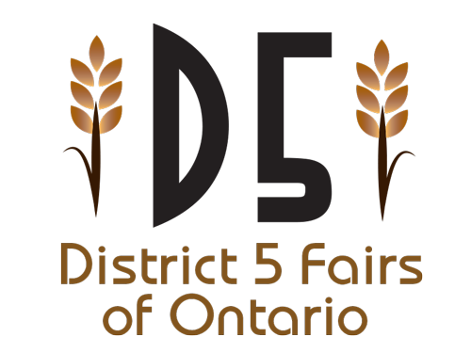**Attention: OAAS District 5 Agricultural Societies and Fairs**

The 6th annual District 5 Ambassador Competition will be held June 25th, 2022 on Collingwood Ontario. **Due to COVID-19 causing may fairs across the province to be canceled or postponed over the past two years, this meant some fairs having 2021-2022 Ambassadors, and some not. This has resulted in an adjustment to the qualifications. Any Ambassador from 2019-2020, 2020-2021 and 2021-2022 can participate in the program if he or she has not won the competition. For additional details or clarification, please connect with the program committee via the contact details at the bottom of this document.**

Being an Ambassador is one of the most rewarding leadership opportunities for rural youth and this program will work to further the opportunities for our district’s ambassadors.

Each ambassador participating in the program will experience and participate in workshops from qualified speakers as well as the interview process, speech and impromptu question that makes up the competition portion of the program, culminating in the awarding of the OAAS District 5 Ambassador.

While we strive to keep costs at a minimum, we do require a small entry fee of **$20** to cover the operating costs surrounding the day.

Sponsorship comes in many forms and all are highly valued. Some forms of sponsorship that we receive include monetary, products, services, signage, and advertising. The District Ambassador Program is primarily a bursary program and the winner receive a bursary to be used toward an aspect of Post-Secondary Education.

Each and every sponsor is acknowledged by a listing in the program during the competition.

Your support of the 5th District 5 Ambassador program is very much appreciated.

If you have any questions, please call 705.717.1707 (Matt) or email us at mattgarwood17@hotmail.com. It is your support that makes an ambassador successful! Thank you for your time and continued support.

Sincerely,

Emma Somerville, Meghan Somerville & Matt Garwood  
OAAS District 5 Ambassador Program Coordinators

**District 5 Ambassador Program Registration and Sponsorship Form**

Please complete the following information and return this form with your cheque made payable to the **OAAS District 5**.The mailing address is listed below. For any questions contact us.

**_______________________________________________________________________**

**FAIR/ AG SOCIETY CONTACT NAME**

**_______________________________________________________________________**

**MAILING ADDRESS** (include R.R.# &/or Box #)

**_______________________________________________________________________**

**TELEPHONE NUMBER FAX NUMBER EMAIL ADDRESS**

**_______________________________________________________________________**

**CONTRIBUTION AMOUNT? REGISTRATION FEE ($20.00)**

_______________________________________________________________________

**ANY OTHER INFORMATION YOU WOULD LIKE TO INCLUDE**

**PLEASE NOTE:**

Deadline is **June 1, 2022** for registration and cheques must be received prior to this date.

**Please mail completed forms & cheques to:**

268 Woodbridge Avenue

Woodbridge, Ontario

L4L 2T2

**OFFICE USE ONLY**

RECEIVED: ____________________________________________________________

DEPOSITED: ___________________________________________________________

RECEIPT NO: ___________________________________________________________